Ensemble Approach for Skin Cancer Classification

Melvin A S,Karunya Institute of Technology and Sciences
Coimbatore,India, melvinas@karunya.edu.in

Abstract—Skin cancer classification is a critical task in dermatological research, necessitating accurate and efficient diagnostic methods.we propose an ensemble model that combines predictions from four pretrained models—ResNet50, Inception, VGG, and EfficientNet—to enhance classification accuracy. The ensemble model aggregates outputs from these models into a 32-value vector, followed by a dense network comprising three layers for final predictions. Leveraging diverse representations learned by each pretrained model, the ensemble model achieves exceptional accuracy of 99% on testing data, with high precision, recall, and F1-score values across all classes. This innovative approach represents a significant advancement in dermatological research, offering a sophisticated solution for skin cancer classification with the potential to yield more accurate and reliable diagnostic outcomes.
Keywords— Skin cancer classification, Deep learning, Ensemble models, Pretrained neural networks, Dermatology, Medical image analysis, HAM10000 dataset, ISIC 2019 dataset, Data preprocessing, Convolutional neural networks, Model ensemble, Classification accuracy, Diagnostic assistance, Image processing, Computer-aided diagnosis

Introduction
Skin cancer is a significant public health concern worldwide, necessitating accurate diagnostic methods to support early detection and treatment. Early diagnosis is of great importance for treating skin cancer as it can be cured better at early stages [1]. Considerable attention has been paid to dermoscopy research in the _eld of dermatological research. Cascinelli et al. [2] applied dermoscopy technique to the clinical diagnosis of malignant melanoma Wei et al. [6] proposed a novel Attention Based DenseUnet network with adversarial training for skin lesion segmentation. Although some research has been done on the computer-aided diagnosis, the problem of insuffcient medical samples and uneven distribution still exists. In recent years, deep learning algorithms have emerged as reliable tools for skin cancer classification, leveraging the wealth of data available through comprehensive datasets such as HAM10000 and ISIC 2019. However, achieving optimal classification accuracy remains a challenge, particularly in the presence of diverse lesion types and variations in image characteristics. To address this challenge, we propose a novel ensemble model that integrates predictions from multiple pretrained models to enhance classification performance. By combining the strengths of ResNet50, Inception, VGG, and EfficientNet, the ensemble model leverages diverse representations learned by each model, enhancing its ability to accurately classify various skin lesions. The ensemble model's architecture, comprising a dense network with three layers, further refines predictions, enabling it to adapt and make accurate classifications across different lesion categories. In this paper, we present a comprehensive overview of our methodology, including data preprocessing, model training, and evaluation. We demonstrate the effectiveness of our approach through rigorous testing on designated datasets, achieving an exceptional accuracy of 99% and high precision, recall, and F1-score values across all classes. Our research represents a notable improvement in dermatological research, providing a sophisticated and effective solution for skin cancer classification with the potential to improve diagnostic outcomes in clinical practice.

II.DATASET
The dataset used in our study encompasses two comprehensive repositories: HAM10000 and ISIC 2019 [7]_[8], both instrumental in advancing the field of dermatological research and aiding in the diagnosis and classification of various skin lesions.
- Actinic keratosis-(akiec)
- Basal cell carcinoma-(bcc)
- Benign keratosis-like lesions-(bkl)
- Dermatofibroma-(df)
- Melanoma-(mel)
- Melanocytic nevi-(nv)
- Vascular lesions-(vasc)
- Squamous cell carcinoma-(scc)
II.a HAM10000 DATASET:
The HAM10000 dataset serves as a pivotal resource, comprising 10,015 dermoscopic images meticulously curated for the detection of pigmented skin lesions. This dataset, is accessible through the ISIC dataset archive, offers a rich assortment of images representing a spectrum of skin conditions. With a thorough breakdown provided, the HAM10000 dataset includes 142 images of vasc, 327 images of akiec, 514 images of bcc, 1099 images of bkl, 115 images of df, 1113 images of nv, and 6705 images of mel. This comprehensive dataset forms the backbone of our research, enabling us to train and evaluate our models effectively.
II.b ISIC 2019 DATASET:
The ISIC 2019 dataset further enriches our study, presenting a collection of 25,331 images capturing eight distinct types of skin lesions. These lesions include melanoma, melanocytic nevus, Basal cell carcinoma, Actinic keratosis, benign keratosis, dermatofibroma, vascular lesions, and Squamous cell carcinoma. Additionally, the dataset incorporates an outlier class, intended for inclusion in the training dataset, along with 8,239 images earmarked for the test dataset.Through the meticulous curation and annotation of these datasets, our research endeavors to leverage the wealth of information encapsulated within these repositories to advance the state-of-the-art in skin cancer classification and diagnosis.

III PREPROCESSING OF IMAGE DATA
In this section, we describe the preprocessing steps applied to the image dataset before feeding it into the neural network model. In our study, we utilized two key datasets: HAM10000 and ISIC 2019, comprising over 10,000 and 20,000 images, respectively. For ISIC 2019, 5% of the dataset was set aside for validation during training, with the remaining 95% used for training. Regarding HAM10000, 10% was reserved for testing, 10% from the remaining for validation, and the rest for training and ensured that each split (training, testing, validation) maintained proper class balance across skin lesion categories. These meticulous data partitioning methods aimed to prevent bias and enhance the robustness and generalization of our deep learning models for skin cancer classification.
III a. IMAGE RESIZING
To standardize the input size and reduce computational complexity, the images were resized to a uniform dimension of 100x100 pixels. This resizing process ensures consistency in the input dimensions across all images in the dataset.
III b. NORMALIZATION OF RGB VALUES
The RGB (Red, Green, Blue) pixel values of the resized images were normalized to the range of [0, 1] by dividing each value by ‘255’. This normalization technique standardizes the pixel intensities, making them more suitable for processing by neural networks. By scaling the RGB values to a common range, the model becomes less sensitive to variations in pixel intensity and improves convergence during training.

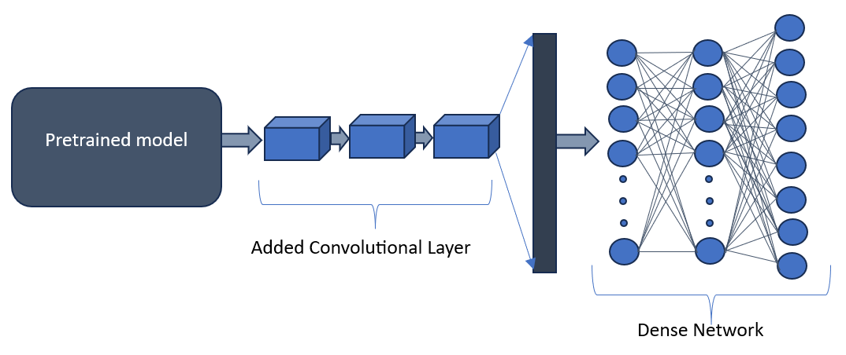
Fig1:Architecture of each individual model after modification

III c.ONE-HOT ENCODING OF TARGET VARIABLE
The target variable, representing the class labels of the images, was encoded using a one-hot encoding scheme. This transformation converts categorical labels into binary vectors, with each vector element corresponding to a distinct class. The one-hot encoding facilitates the training of the neural network model by providing a numerical representation of the categorical labels. Additionally, it enables the model to predict multi-class classification tasks effectively. These preprocessing steps ensure that the input data is appropriately prepared for training the neural network model. By standardizing the image dimensions, normalizing the pixel values, and encoding the target variable, the dataset is primed for effective learning and inference tasks.
III d. DATA AUGMENTATION
Data augmentation techniques were employed to enhance the diversity of the training dataset:
• Random Rotation: Images were randomly rotated to improve the model's orientation invariance.
• Random Flipping: Horizontal flipping was applied to introduce variations in object orientation.
• Random Zooming: Images underwent random zooming to enhance robustness to object scales and perspectives.
These techniques augmented the training dataset, leading to improved model generalization and performance.

IV a. SPLITING OF DATA
To ensure robust training, validation, and testing of our models across all classes present in the HAM10000 and ISIC 2019 datasets, we implemented a meticulous data splitting strategy. The HAM10000 dataset was initially divided into training and testing subsets. In this step, each class was proportionally represented, with 90% of the data from each class allocated to the training set and the remaining 10% to the testing set. This ensured that the model would be exposed to a balanced distribution of samples from each class during training and evaluation. Subsequently, the training data underwent an additional splitting process to create a validation subset. Again, this splitting was conducted with careful consideration of class proportions, ensuring that each split contained an equitable representation of samples from all classes. Specifically, 10% of the training data was set

aside for validation purposes, while the remaining 90% constituted the actual training set. In contrast to the HAM10000 dataset, the ISIC 2019 dataset was fully utilized for training, without the need for additional splitting. This decision was made to maximize the available data for training purposes and to capitalize on the diverse range of lesions present in the dataset.By adopting this comprehensive data splitting strategy, our models were trained, validated, and tested using a balanced representation of samples from all classes in both datasets. This approach not only ensured that the models were exposed to a diverse range of lesion types during training but also facilitated robust evaluation across all classes during testing.
V a. TRAINING OF PRETRAINED MODEL
In our research, we have utilized four different pre-trained models: ResNet50, Inception, VGG, and Efficient-Net. Employing a consistent methodology, we fine-tuned each model by enabling training of all layers, allowing for adaptation to the distinctive features present in dermatoscopic images. Gessert et al. [9]combined the crops both by simple averaging and a meta learning strategy to improve the accuracy of model classification. To overcome The insufficient data problems, researchers have used transfer learning and generative adversarial networks (GANs), which have achieved excellent results in CAD [3]_[5]. Ghazi et al. [4] used transfer learning to _ne-tune the three powerful and popular deep learningarchitectures, namely GoogLeNet, AlexNet, and VGGNet. Through transfer learning, CNNs can converge faster. Augmenting the architecture of each model, we integrated three consecutive convolutional layers with varying filter configurations: 100, 250, and 500 filters, ensuring comprehensive feature extraction across different scales and complexities inherent in the images. Following the convolutional layers, three densely connected layers with Rectified Linear Unit (ReLU) activation functions were incorporated. Similarly, the output layers of all models comprised eight neurons, corresponding to the various categories of skin lesions, employing softmax activation functions to compute class probabilities. For optimization, we employed the Stochastic Gradient Descent optimizer, navigating the weight space to minimize the categorical cross-entropy loss function, pivotal in multi-class classification tasks. Throughout the training regimen, accuracy served as our primary evaluation metric, offering insights into the models' proficiency in correctly classifying dermatoscopic images. Data augmentation techniques were consistently applied during training to diversify the dataset and enhance the models' generalization capabilities. Each model underwent rigorous training for 100 epochs, iteratively learning from augmented input images and updating its weights to minimize categorical cross-entropy loss. This extensive training regimen facilitated the progressive improvement of each model's ability to discern between different types of skin lesions, harnessing both the inherent knowledge encoded in the pre-trained architectures and the task-specific adaptations introduced through fine tuning and augmentation. The Size and parameters of the models differ from each of them that impacts their performance.
V b. RESNET50 MODEL
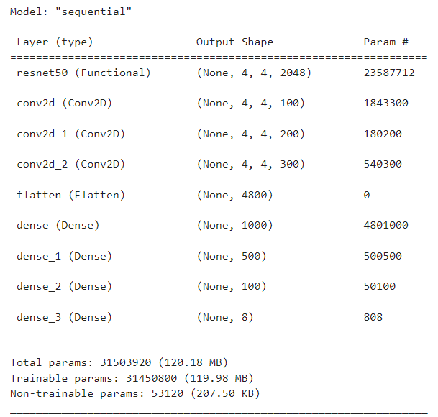
Fig2: resnet50 model summary
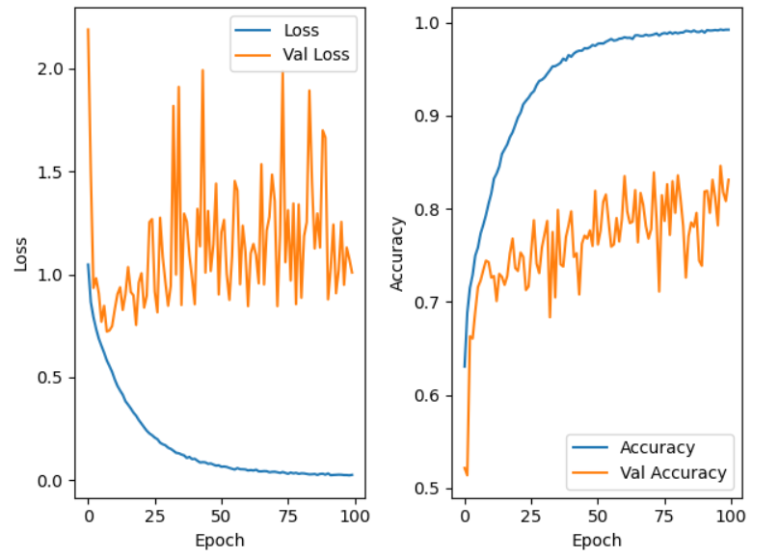
Fig3:(left)Graph representation of Loss with Epoch
Fig3:(right)Graph representation of Accuracy with Epoch

V c. INCEPTION MODEL

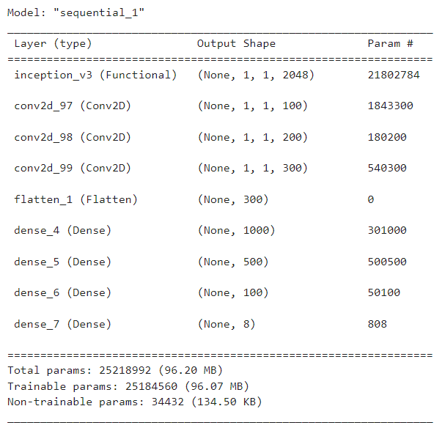
Fig4: inception model summary

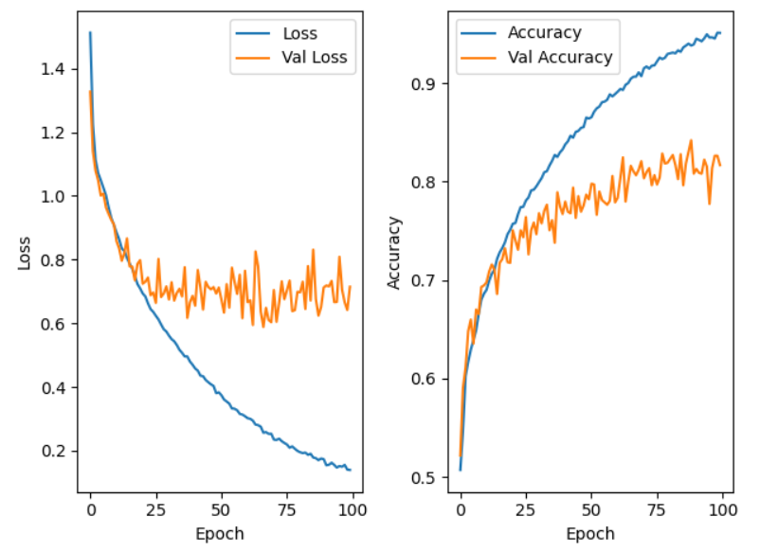
Fig5:(left)Graph representation of Loss with Epoch
Fig5:(right)Graph representation of Accuracy with Epoch

V d. EFFICIENTNET MODEL
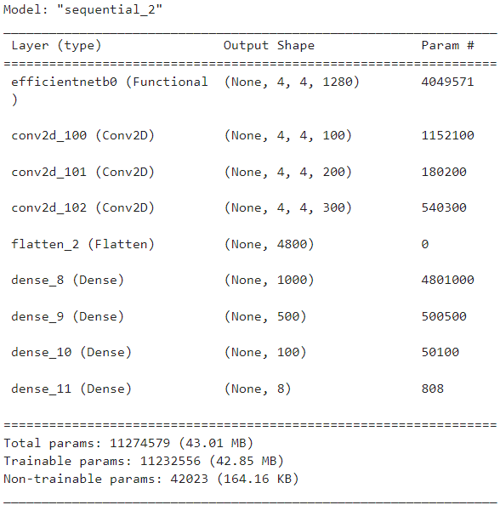
Fig2: efficientnet model summary

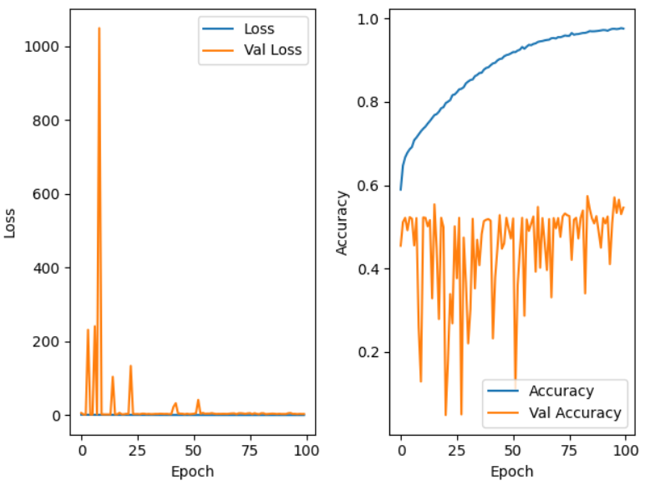
Fig6:(left)Graph representation of Loss with Epoch
Fig6:(right)Graph representation of Accuracy with Epoch

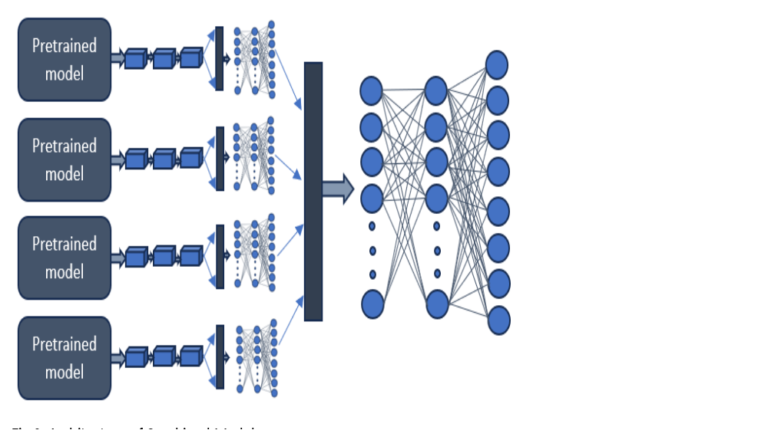
Fig9: Architecture of Combined model
V e. VGG19 MODEL

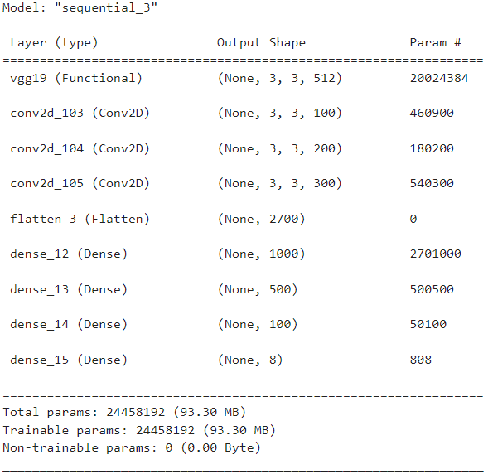
Fig7:vgg19 model summary
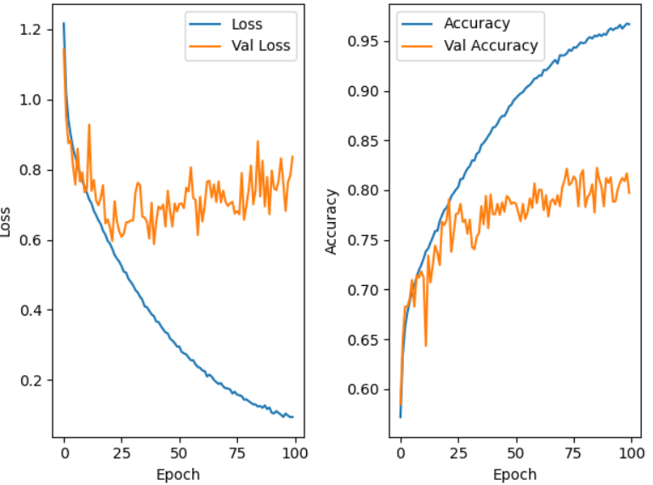
Fig8:(left)Graph representation of Loss with Epoch
Fig8:(right)Graph representation of Accuracy with Epoch

Table 1: Metrics of each model on 5% Test Data of HAM1000
Model | Accuracy (%) | Precision (%) | Recall (%) | F1 score (%)
Resnet50 | 96.28 | 85.62 | 77.74 | 80.19
Inception | 94.77 | 82.38 | 78.27 | 79.48
EfficientNet | 64.92 | 12.04 | 15.24 | 13.44
VGG19 | 93.37 | 83.08 | 76.14 | 77.92

VI a. COMBINED MODEL
A Novel ensemble model designed to enhance skin cancer classification by combining predictions from four pretrained models: ResNet50, Inception, VGG, and EfficientNet. The output of each model, consisting of 8 values, is aggregated into a 32-value vector. Subsequently, a dense network comprising three layers is introduced. The first layer consists of 100 neurons, the second layer has 50 neurons, and the final layer comprises 8 neurons with a softmax activation function. Rectified Linear Unit (ReLU) activation functions are employed in the first two layers. During training, these 32 predicted values serve as inputs to the dense network, enabling it to make final predictions. For inference, the outputs generated independently by the four models are combined and fed into the dense network for the final prediction.
The model was trained with HAM10000 dataset with proper proportion of classes (95%) by predicting the output of each model and using this output to train the next dense network.
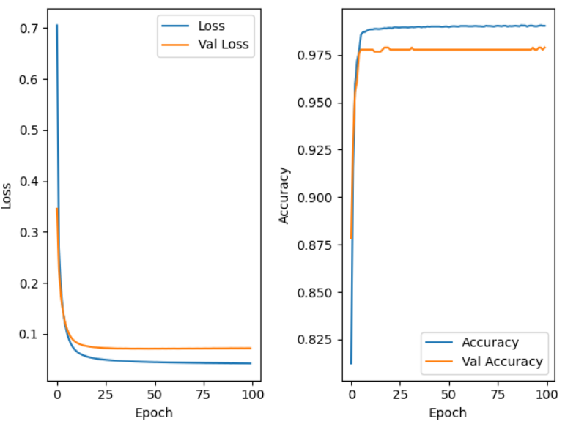 Fig 10:(left)Graph representation of Loss with Epoch of Combined model
Fig 10:(right)Graph representation of Accuracy with Epoch of Combined model
This ensemble approach capitalizes on the diverse representations learned by each pretrained model, enhancing classification accuracy. The introduction of the dense network provides further refinement and fine-tuning, facilitating accurate predictions across various skin lesion categories. By integrating these components, the ensemble
model offers a sophisticated and effective solution for skin cancer classification, representing a significant advancement in dermatological research with the potential to yield more accurate and reliable diagnostic outcomes.
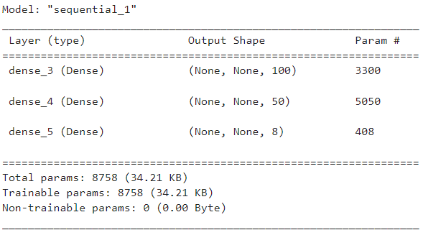
Fig 11: Combined model Summary
VII a. RESULT
Following testing with the designated testing data, the final ensemble model demonstrated exceptional performance, achieving an accuracy of 99%. The precision, recall, and F1-score metrics provide insights into the model's performance across different classes. Notably, the model achieves high precision, recall, and F1-score values across all classes, indicating its robustness and effectiveness in accurately classifying skin lesions. Overall, the ensemble model's impressive accuracy and comprehensive performance metrics underscore its potential as a valuable tool in dermatological research and clinical practice, offering reliable and precise skin cancer classification outcomes.
Overall, the ensemble approach presented in this study holds promise for improving diagnostic accuracy in clinical practice, potentially leading to earlier detection and treatment of skin cancer. Its integration into computer-aided diagnosis systems could enhance the efficiency and reliability of dermatological assessments, ultimately benefiting patient care and outcomes.
Table 2: Metrics of Combined model on 5% Test Data of HAM1000
Model | Accuracy (%) | Precision (%) | Recall (%) | F1 score (%)
Combined Model | 99.39 | 99.54 | 99.29 | 99.42

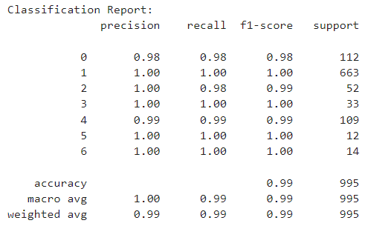
Fig 12: Classificaation Report of Combined model

REFERENCES
[1] N. Codella, J. Cai, M. Abedini, R. Garnavi, A. Halpern, and J. R. Smith,``Deep learning, sparse coding, and SVM for melanoma recognition in dermoscopy images,'' in Proc. Int. Workshop Mach. Learn. Med. Image Cham, Switzerland: Springer, 2015, pp. 118_126.
[2] N. Cascinelli, M. Ferrario, T. Tonelli, and E. Leo, ``A possible new tool for clinical diagnosis of melanoma: The computer,'' J. Amer. Acad. Dermatol., vol. 16, no. 2, pp. 267_361, 1987.
[3] I. Goodfellow, J. Pouget-Abadie, M. Mirza, B. Xu, D. Warde-Farley,S. Ozair, A. Courville, and Y. Bengio, ``Generative adversarial nets,'' in Proc. Adv. Neural Inf. Process. Syst., 2014, pp. 2672_2680.
[4] M. M. Ghazi, B. Yanikoglu, and E. Aptoula, ``Plant identification using deep neural networks via optimization of transfer learning parameters,'' Neurocomputing, vol. 235, pp. 228_235, Apr. 2017.
[5] K. M. Hosny, M. A. Kassem, and M. M. Foaud, ``Classification of skin lesions using transfer learning and augmentation with alex-net,'' PLoS ONE, vol. 14, no. 5, May 2019, Art. no. e0217293.
[3] I. Goodfellow, J. Pouget-Abadie, M. Mirza, B. Xu, D. Warde-Farley,S. Ozair, A. Courville, and Y. Bengio, ``Generative adversarial nets,'' in Proc. Adv. Neural Inf. Process. Syst., 2014, pp. 2672_2680.
[6] Z.Wei, H. Song, L. Chen, Q. Li, and G. Han, ``Attention-based DenseUnet network with adversarial training for skin lesion segmentation,'' IEEE Access, vol. 7, pp. 136616_136629, 2019.
[7] M. Combalia, N. C. F. Codella, V. Rotemberg, B. Helba, V. Vilaplana, O. Reiter, C. Carrera, A. Barreiro, A. C. Halpern, S. Puig, and J. Malvehy,``BCN20000: Dermoscopic lesions in the wild,'' 2019, arXiv:1908.02288.[Online]. Available: http://arxiv.org/abs/1908.02288
[8] P. Tschandl, C. Rosendahl, and H. Kittler, ``The HAM10000 dataset, a large collection of multi-source dermatoscopic images of common pigmented skin lesions,'' Sci. Data, vol. 5, no. 1, Dec. 2018, Art. no. 180161.
[9] N. Gessert, T. Sentker, F. Madesta, R. Schmitz, H. Kniep, I. Baltruschat,R. Werner, and A. Schlaefer, ``Skin lesion diagnosis using ensembles, unscaled multi-crop evaluation and loss weighting,'' 2018,arXiv:1808.01694. [Online]. Available: http://arxiv.org/abs/1808.01694
[10] A. Berson and S. Smirth , Transients in Power Systems, 3rd Edition, McGraw Hill, 1998, ISBN:81-265-0280-0.
[11] Larry M.Stephens, “Consensus Ontologies in Web Page Design”, IEEE Transactions On Pattern Recognition and Machine Intelligence, vol.29, no.4, pp. 120-135, September 1999.
[12] K.E.Barner, ”Joint Region Merging Criteria”, Proceedings of International Conference on Image Processing,vol.25, pp. 108-111Sept.2007.
[13]http://www.vicomsoft.com/knowledge/reference/firewalls1.html.
[14]https://www.researchgate.net/figure/Architecture-of-Resnet50_fig1_379327710
[15] https://www.researchgate.net/figure/EfficientNet-elite-B9-V2-architecture_fig4_365951796
[16]https://www.geeksforgeeks.org/inception-v4-and-inception-resnets/
[17]https://www.researchgate.net/figure/VGG-19-Architecture-39-VGG-19-has-16-convolution-layers-grouped-into-5-blocks-After_fig5_359771670

